**EE324 Control Systems Lab**

Problem sheet 8

Tarun Sai Goddu | 190070024

**Question 1**

Given

G(s) = s+k1/s+k2

K1= 5k2

G(s) = s+5k2/s+k2

Part (a)

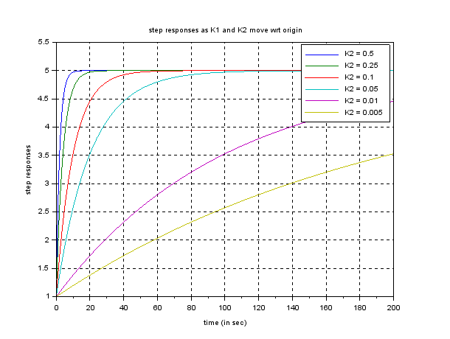

Figure 1: Step responses

We notice that with K2 increasing, there is less rise time in the stepping response, which is the transitory response that starts earlier when we have increased the polar magnitude, which is not desirable by the lag compensator since it is necessary to influence only the constant state, and not the instant temporary reaction.

1. Part (b)

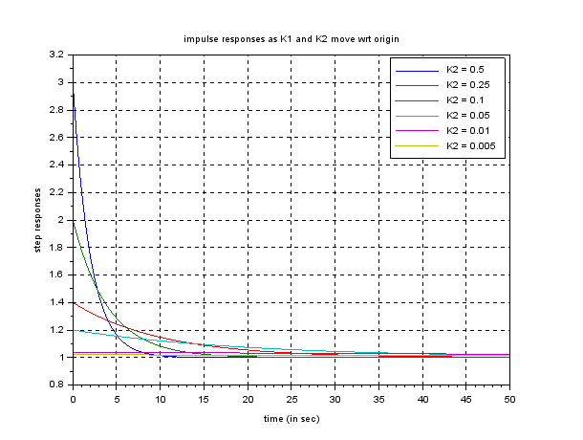

Figure 2: Impulse responses

The impulse response of the system decays much faster and the initial value of response (@ t = 0) also increases as we increase the value of K2

**Scilab Code:**

s = poly(0,'s');

K2 = [0.5, 0.25, 0.1, 0.05, 0.01, 0.005];

K1 = K2.*5;

t1 = 0:0.01:200;

t2 = 0:0.001:50;

y1 = zeros(length(t1), length(K2));

y2 = zeros(length(t2), length(K2));

for i = 1: length (K2)

sys = syslin('c', (s+K1(i)), (s+K2(i)));

y1(:, i) = csim('step', t1, sys);

y2(:, i) = csim('impulse', t2, sys);

end

scf();

xgrid();

plot(t1, y1, 1:length(K2));

xtitle("step responses ", "time (in sec)", "step responses");

scf();

xgrid();

plot(t2, y2, 1:length(K2));

xtitle("impulse responses", "time (in sec)", "step responses");

**Question 2**

**G(s) =** 4/(s+1)(s^2+1)(s^2+4)

**Part(a)**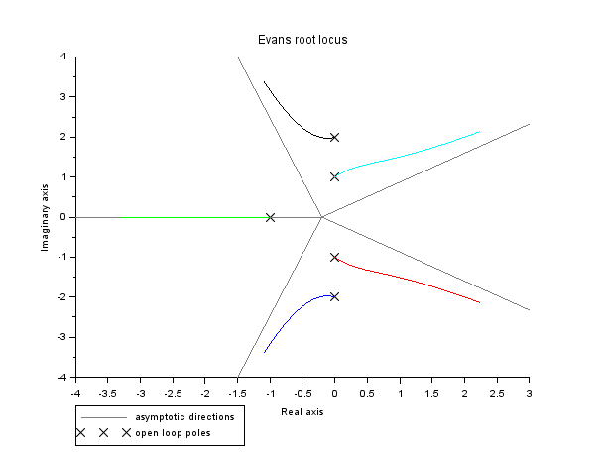

Figure 3: Root Locus of G(s)

**Part(b)**

The transfer function becomes:

G(s) = 4/(s+4)((s+3)^2+1)((s+3)^2+4)

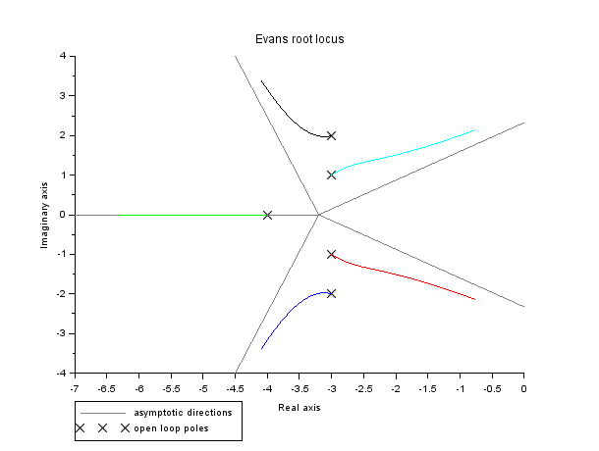

Figure 3: Root Locus of G(s) 2B

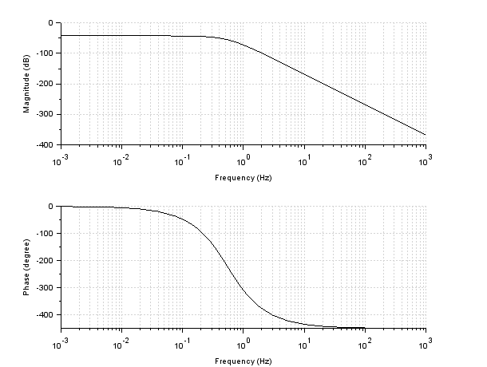

Figure 4: Bode Plot

**Part(c)**

For 2 phase crossover frequencies we use the following transfer function:

G(s) = 4(s+16)^4/ s+4)((s+3)^2+1)((s+3)^2+4)

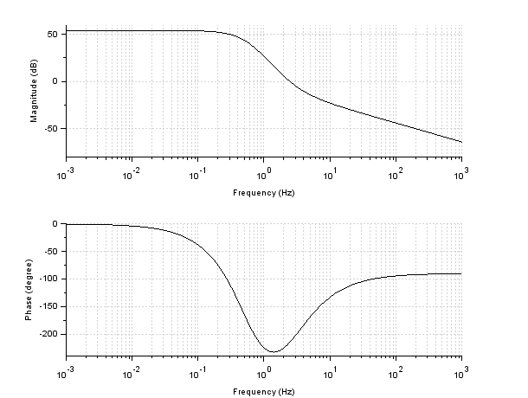

Figure 4: Phase crossover frequency

**Part(d)**

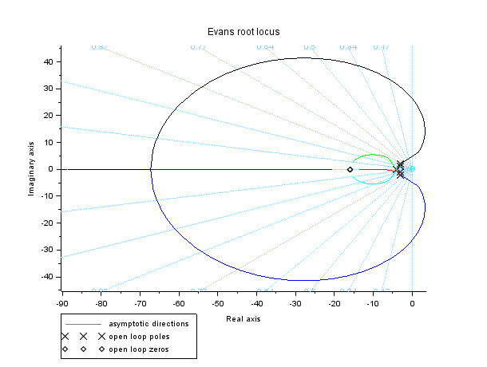

Figure 5: Root locus

We can observe that 2 places in which one branch of the root locus intersects the imaginary axis, therefore two frequencies result in the reversing of the phase.

**Scilab code:**

s = poly(0,'s');

num = 1;

den = (s^3+11*s^2+31*s+21);

kp = 69.5;

kd = 17.5

G = num/den;

G = G*(kp+kd*s);

H = G/(1+G);

sys = syslin('c', G);

scf();

evans(sys, 100);

k = 3;

G1 = 4/(((s+k)+1)*((s+k)^2+4));

sys1 = syslin('c', G1);

scf();

evans(sys1, 100);

scf();

bode(sys1);

sys2 = sys1*((s+100)^2);

scf();

bode(sys2);

scf();

evans(sys2,1000)

**Question 3**

For matching the magnitude plot, we can obtain transfer function as follows:

G(s) = k*(s+1)/(s+5)(s+10)(s+100)

k= 10^(-75/20)*5000

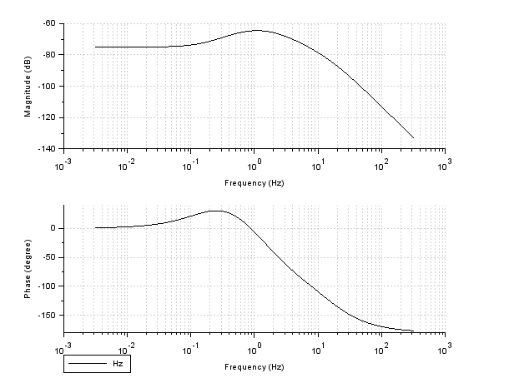

Figure 5: Minimum Phase

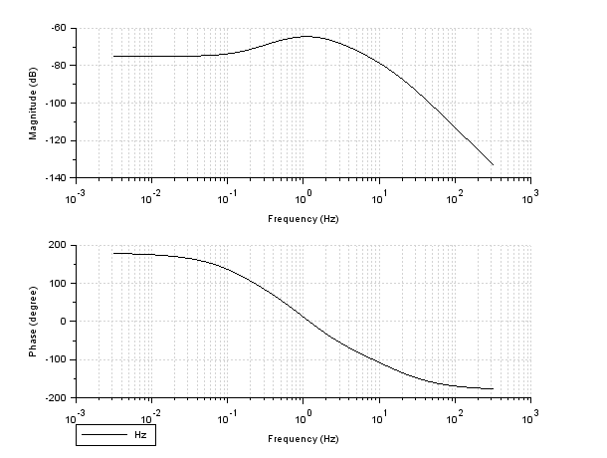

Figure 5: Non Minimum Phase

**Scilab code:**

clc();

s = poly(0,'s');

G = 4/((s^2+2*s+4)*(s+0.1));

G = syslin('c',G);

evans(G,40);